**Screenshot starting page:**

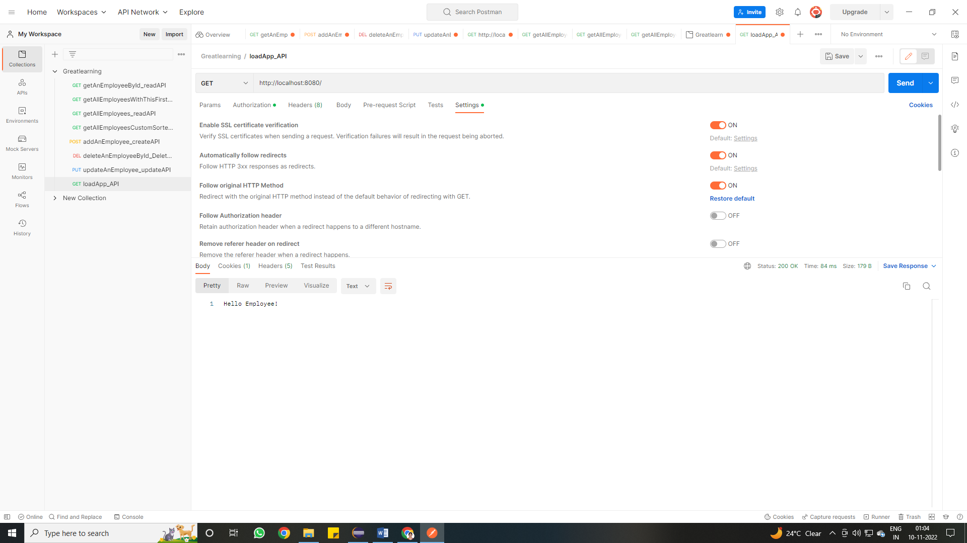

**Screenshot list all employees:**

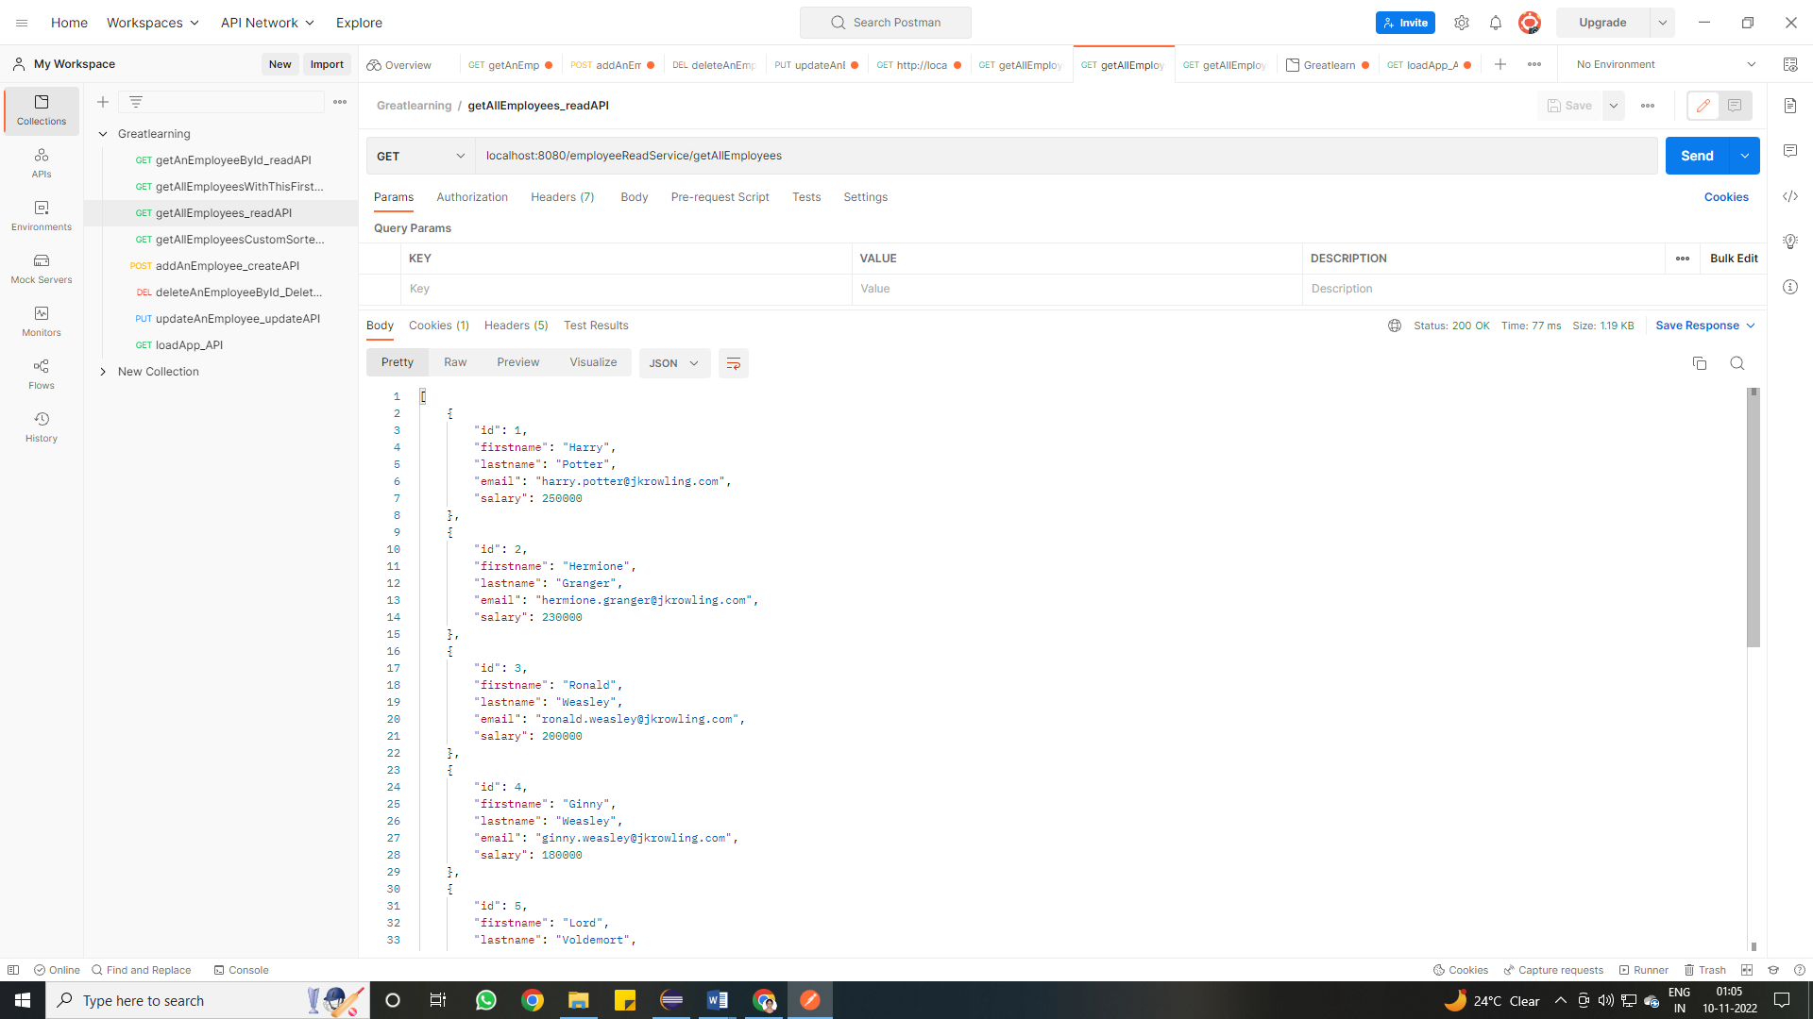

**Screenshot list an employee with id 2**

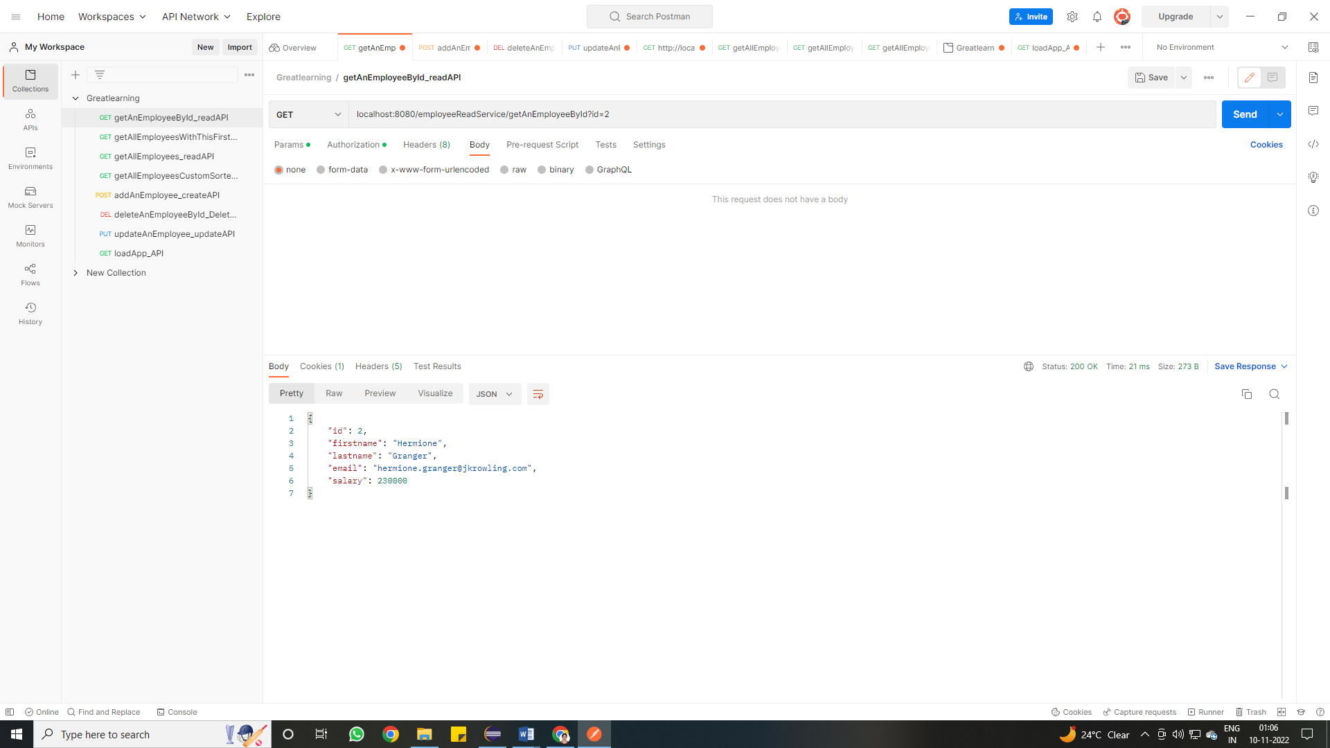

**Screenshot list all employees with this first name:**

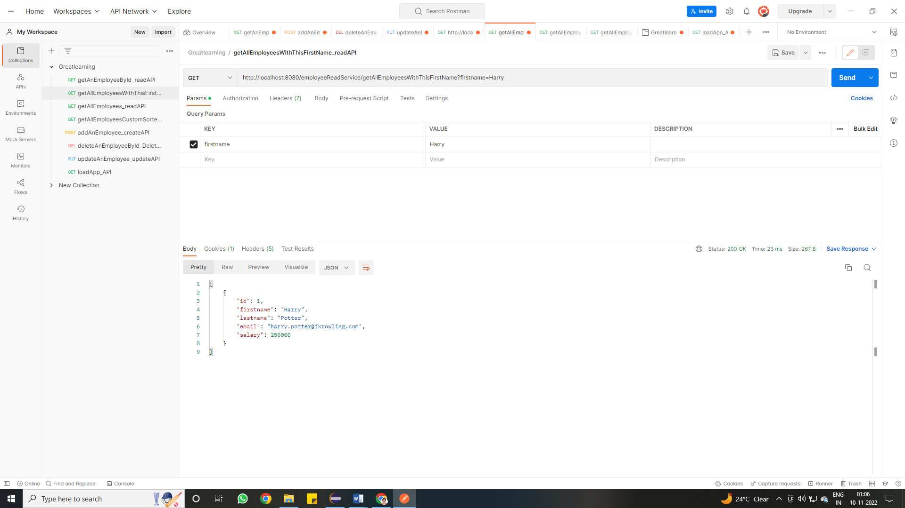

**Screenshot list all employees custom sorted by first name: (desc order shown)**

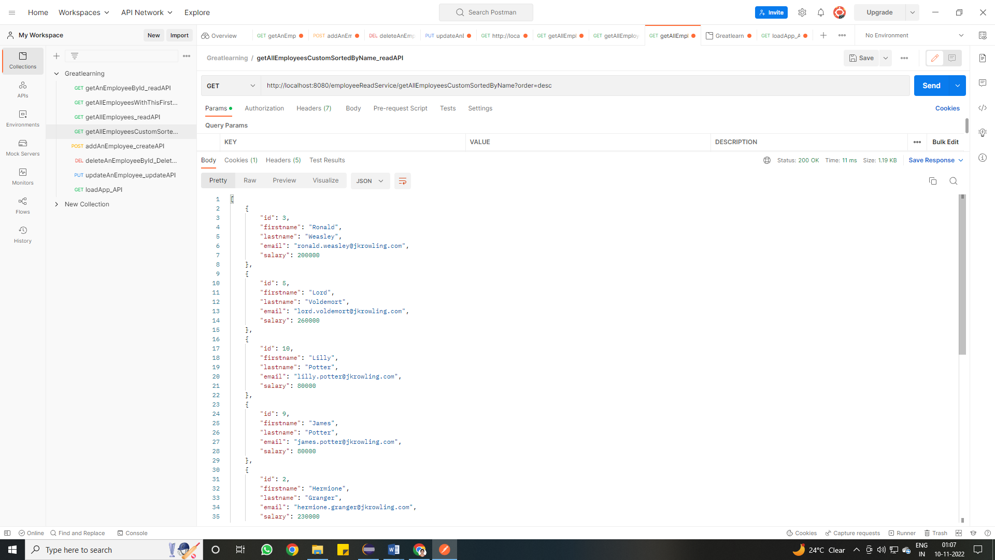

**Screenshot add an employee:**

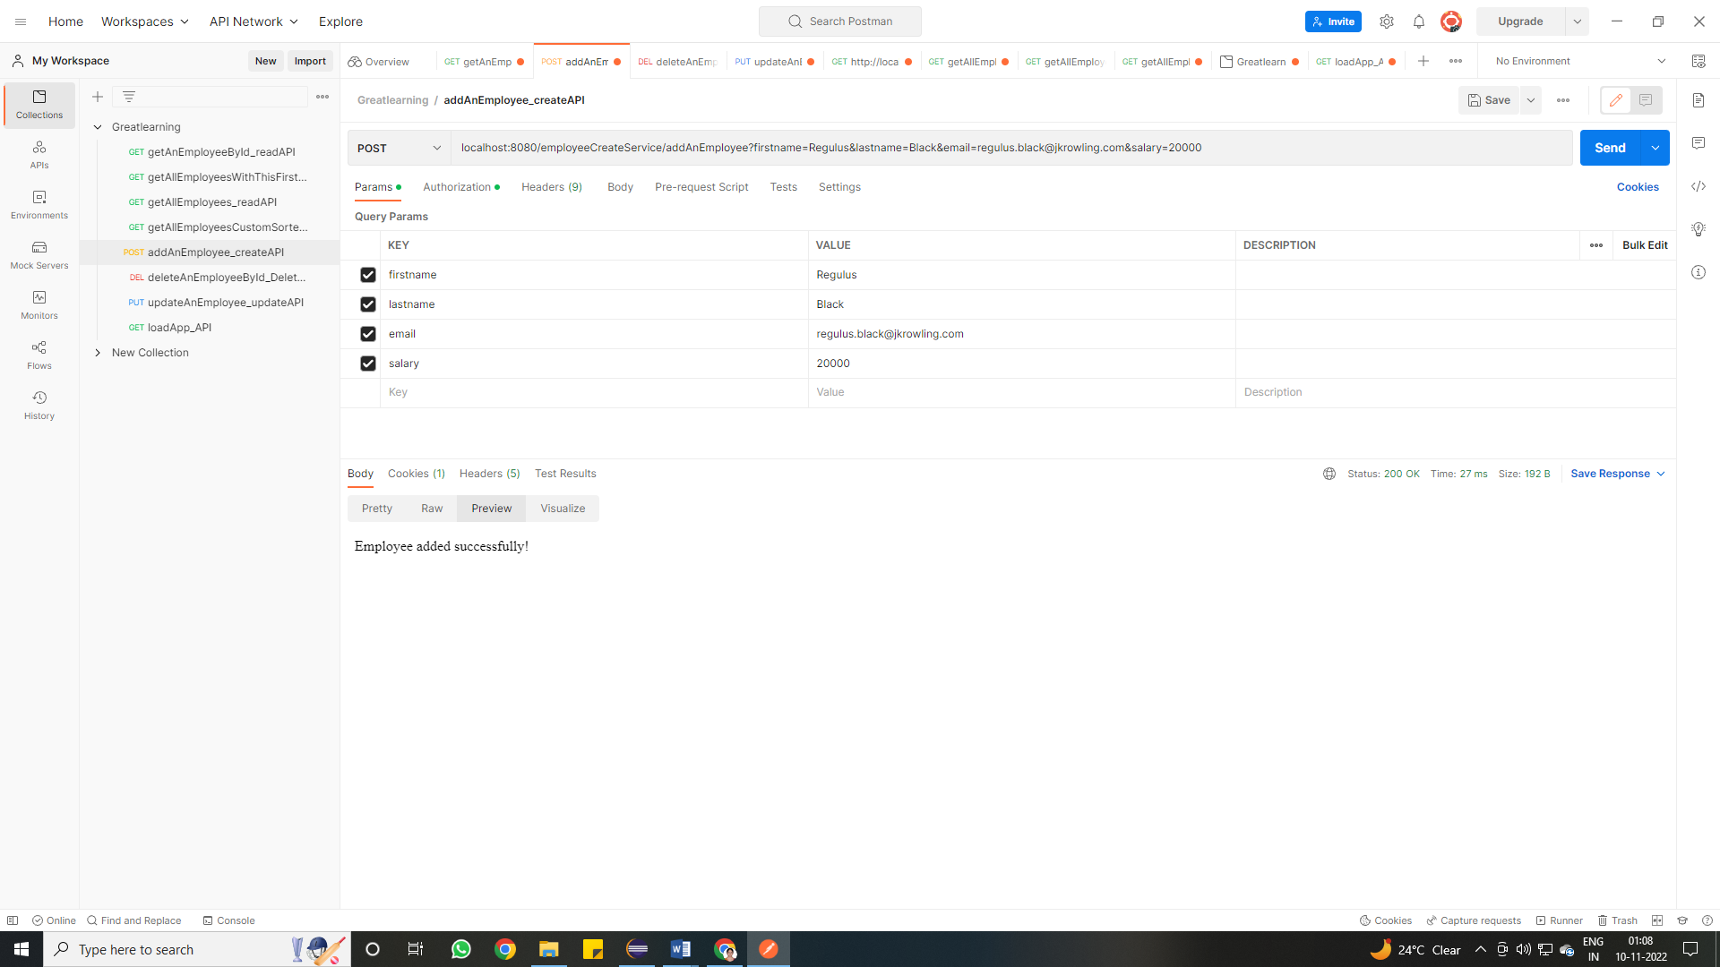

**Screenshot delete an employee with given id:**

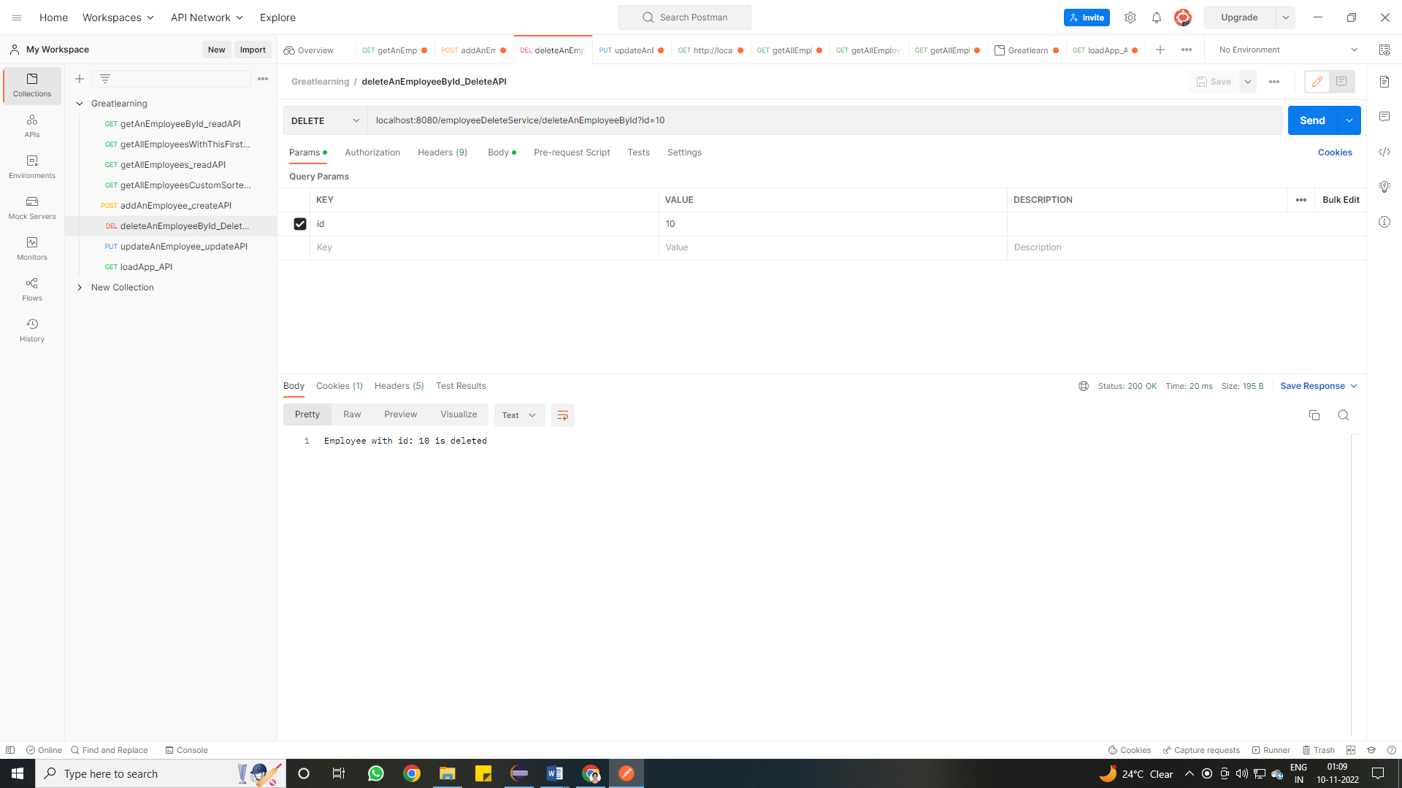

**Screenshot update an employee:**

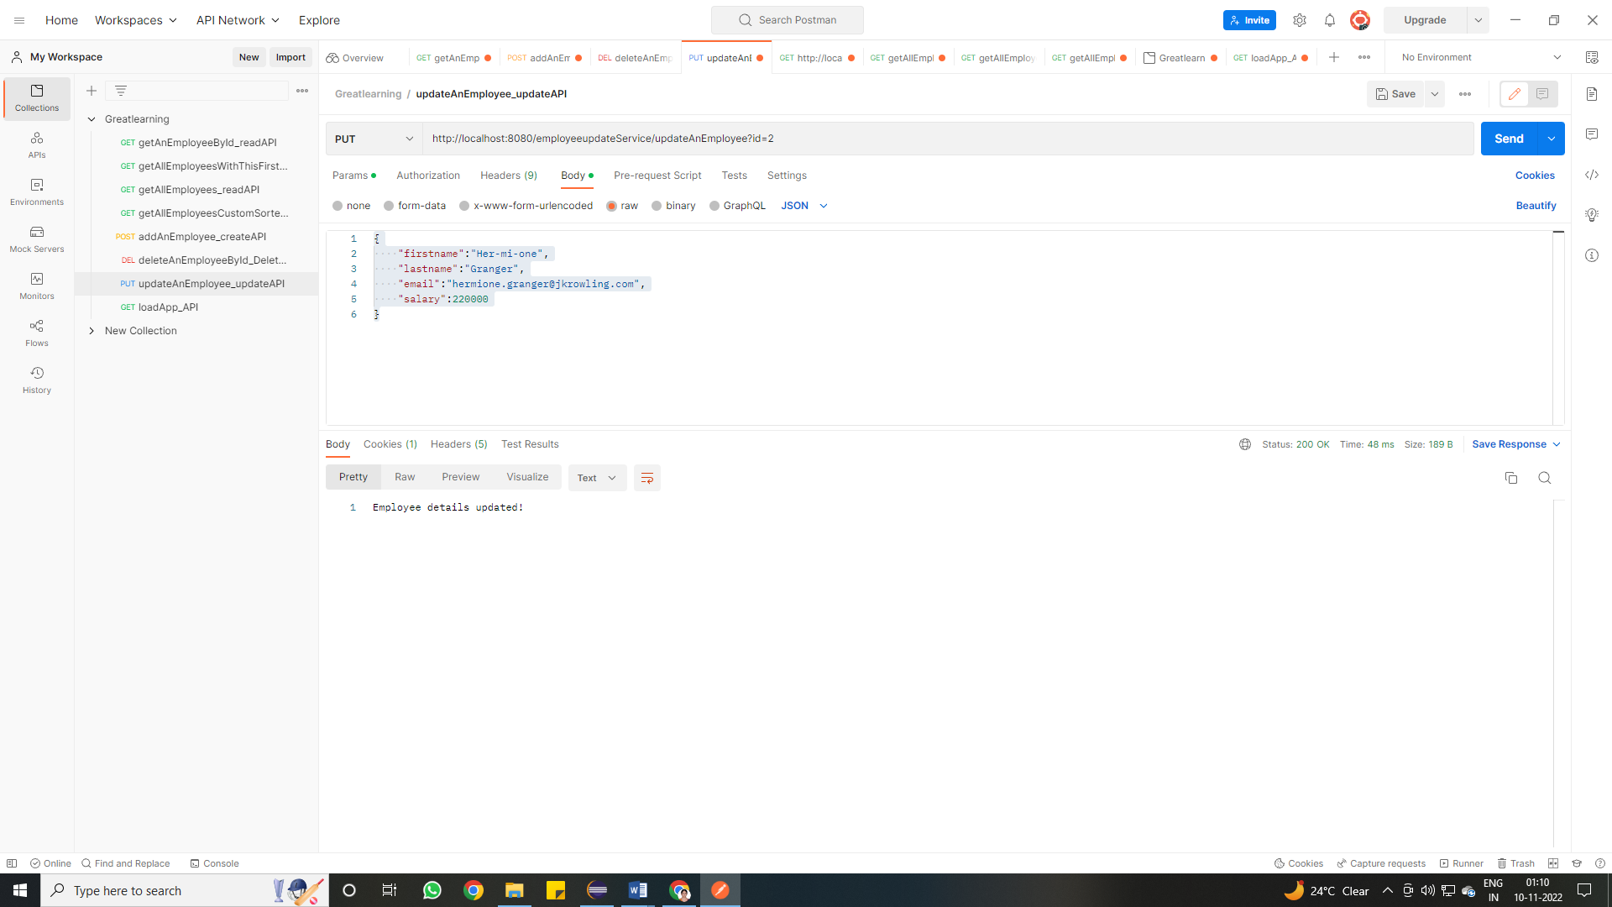

**Screenshot secured login with ADMIN role:**

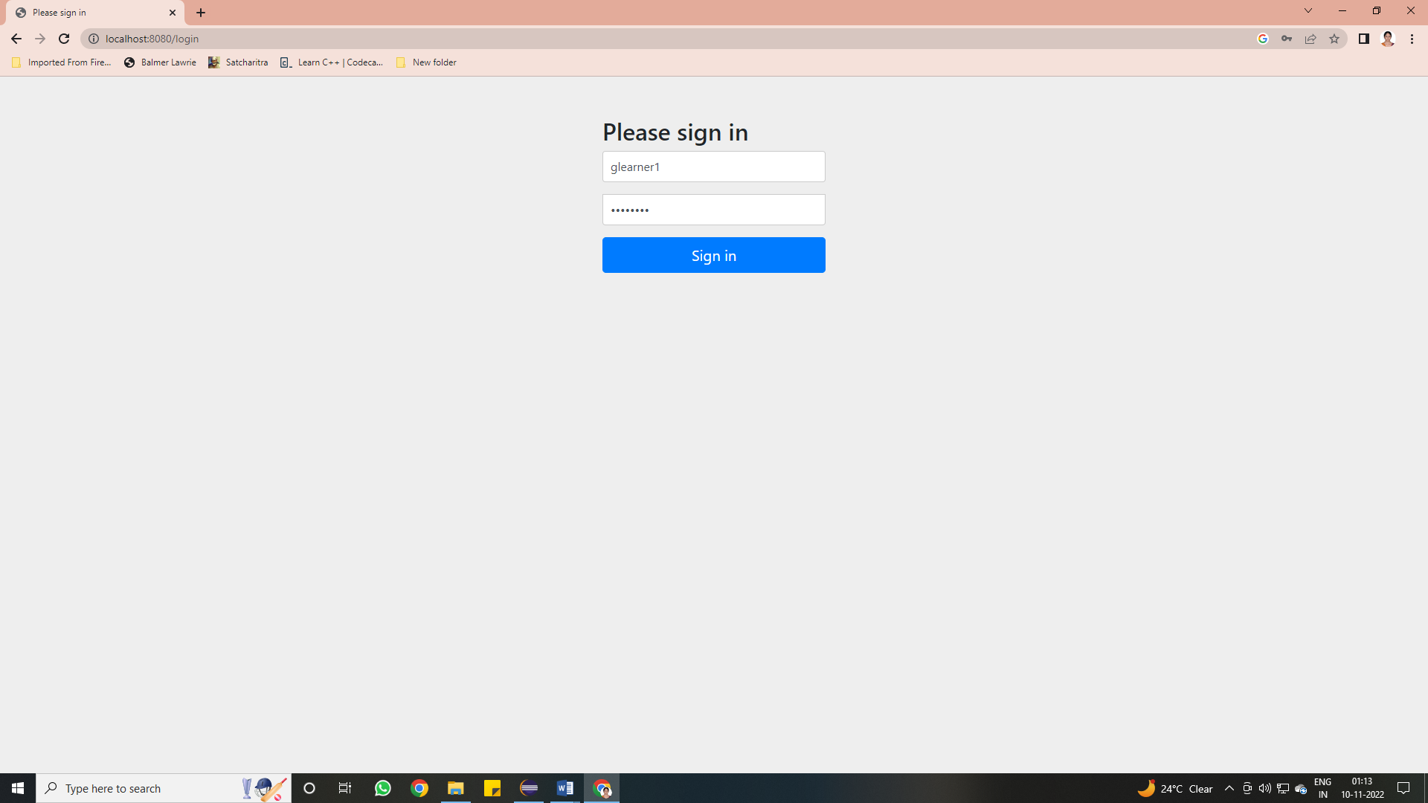

**Screenshot login success:**

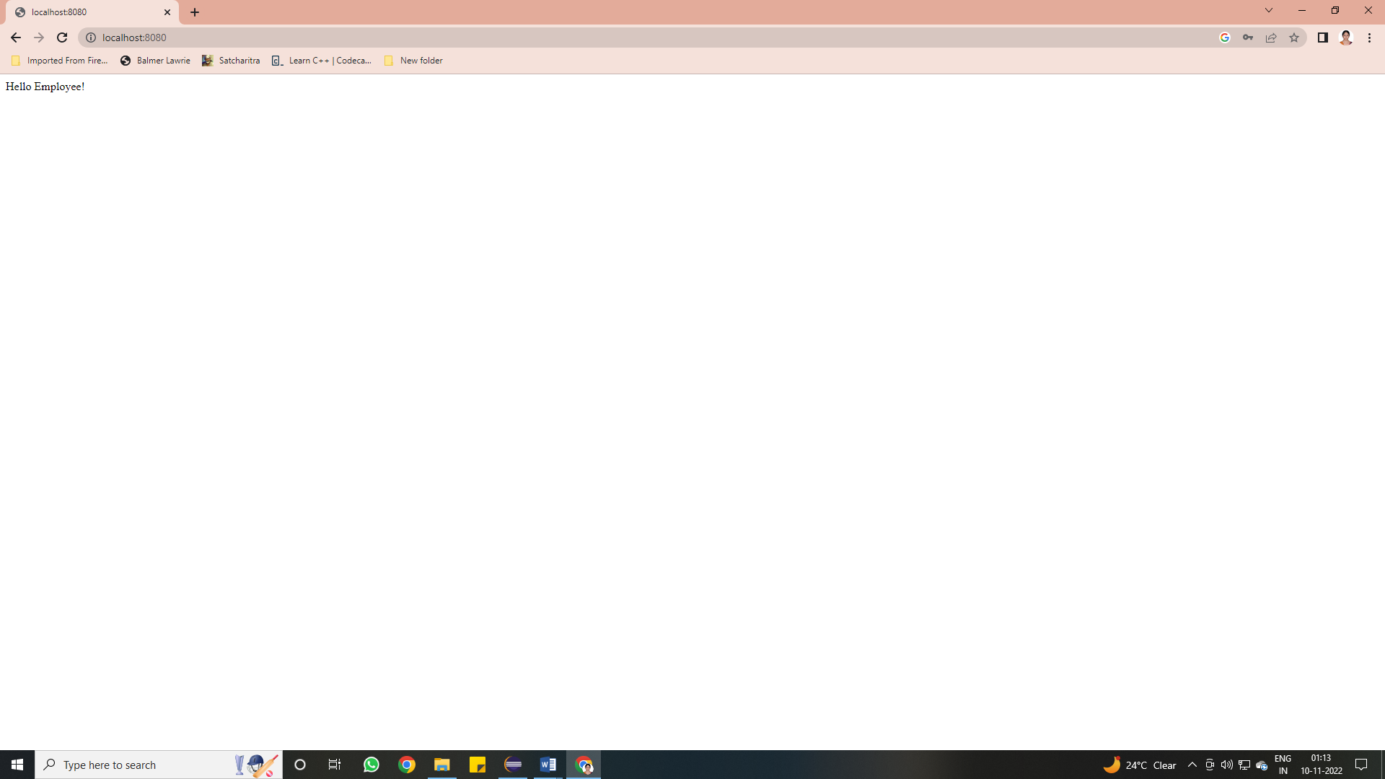

**Screenshot add user:**

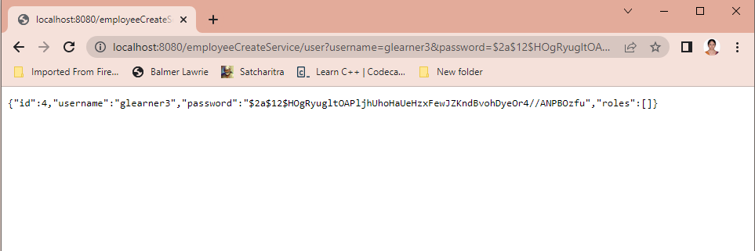

**Screenshot add role:**

